

CMPSC 462 (Spring 2025)

Data Structures

Movie Recommendation

Preliminary Report

Earl Hibbs, Jack Demtshuk, Nicholas Taweel, Ishaq Halimi

Instructor: Vinayak Elangovan

Submitted On: 04/01/2025

**TABLE OF CONTENTS**

|  |  |  |
| --- | --- | --- |
| 1 | ABSTRACT | **3** |
| 2 | GOAL | **3** |
| 3 | OBJECTIVE | **3** |
| 4 | UML DIAGRAM | **4** |
| 5 | CONTRIBUTION PLAN | **5** |

**1 – ABSTRACT**

The idea that we came up with for this project is to create a movie recommendation system. The user of the program will be able to ask for recommended films based on certain criteria they input. Examples of this include asking for recommendations based on director, year of release, genre or lead actor. The system will analyze several films that are already inside of a database, which will then identify the films closest to the criteria by utilizing graphs and trees. The tree system can be used to search the database and move in the direction of corresponding attributes, while the graph system can be used to compare a film to other films on a larger scale.

**2 – GOAL**

The goal of this project is to utilize graphs and trees to their fullest in order to perform a large-scale system. A movie recommendation system is a complex system that has many moving parts and features. Creating a functional system like this allows us to demonstrate a deeper understanding of how graphs and trees work independently and together. A project like this also allows us to credit ourselves with significant work that can be useful on our resumes and job searching in the future. This project will also allow us to experience a more realistic work environment when it comes to partners and teamwork, including how to split work evenly and develop leadership skills.

**3 – OBJECTIVE**

For our project, we have broken down into specific tasks. (1) We will be researching and planning how to implement the recommendation system. Namely, we will be going over trees and graphs and figuring out how to incorporate them through our recommendation system. (2) We will find a dataset that we would be comfortable with implementing in our project. We will refactor this dataset into something that would be clean for Python to read. Through our research, we would implement the graphs and trees. (3) Graphs will be used to represent tags that movies have which are represented through connections, and the number of connections to the graph would correspond to a stronger connection. (4) We would use trees to divide the movie genres up into smaller subcategories, and suggest movies based off the position of the movie in the tree. (5) We need to implement a recommendation engine, that takes the information provided by the tree and graph construction and use it to output a new movie. (6) Additionally, we need to implement an interface or some kind of way to have the user interact with our system. (7) Finally, we will test everything for debugging.

**4 – UML DIAGRAM**

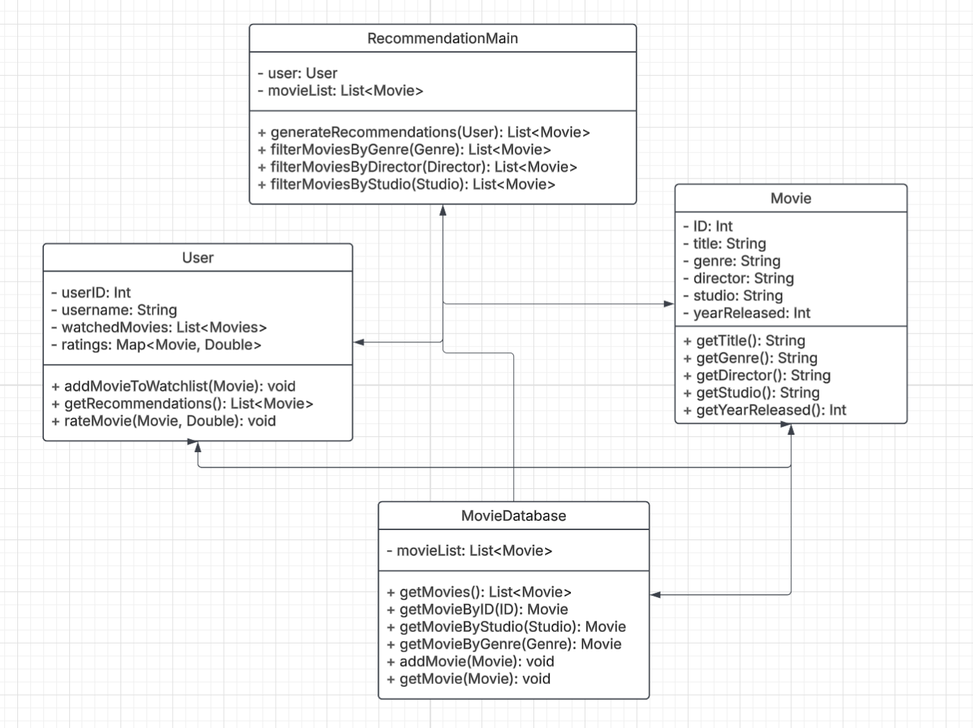

**5 – CONTRIBUTION PLAN**

Here is how the work is being divided:

**Earl Hibbs –** Oversee the project, GitHub management, set tasks and structure code and files accordingly, documentation, additional coding assistance and cleaning where needed.

**Nicholas Taweel –** Graph design for movie tags, implement the recommendation algorithm, incorporate graphs into recommendation logic.

**Jack Demtshuk –** Tree design for movie genres, incorporate trees into the recommendation logic, test code for bugs.

**Ishaq Halimi –** Find dataset, dataset compilation and integration, implement user interface.